***Solution Section* 2.6 − Forced Harmonic Motion**

***Exercise***

A 1-*kg* mass is attached to a spring and the system is allowed to come to rest. The spring-mass system is attached to a machine that supplies external driving force  *Newtons*. The system is started from equilibrium; the mass is having neither initial displacement nor velocity. Ignore any damping forces.

1. Find the position of the mass as a function of time
2. Place your answer in the form . Select an  near the natural frequency of the system to demonstrate the "beating" of the system. Sketch a plot shows the "beats:" and include the envelope of the beating motion in your plot.

***Solution***

***a*)** 

 







***b*)**  





*Mean frequency*: 



*Half difference*: 













If we choose  near to 

That implies to:  and 





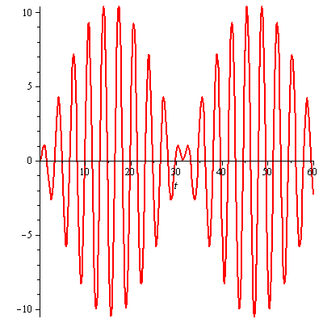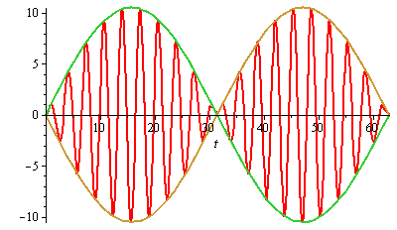

***Exercise***

Find a particular solution to the differential equation using undetermined coefficients. Find and plot the solution of the initial value problem. Superimpose the plots of the transient response and the steady state solution.

 

***Solution***

The particular solution: 















The particular solution (***steady-state*** ***solution***):



The homogeneous eq.: 

The characteristic eq.: 



 













***Transient response*** ***solution***: 

The general solution: 

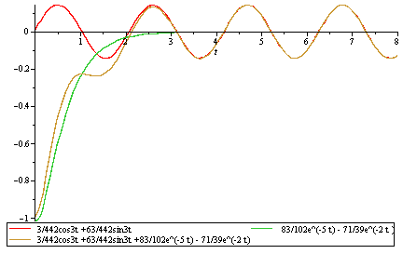

***Complex Method***



The particular solution: 

























The particular solution (***steady-state*** ***solution***): 

***Exercise***

Find a particular solution to the differential equation using undetermined coefficients. Find and plot the solution of the initial value problem. Superimpose the plots of the transient response and the steady state solution.



***Solution***



The particular solution: 



























The homogeneous eq.: 

The characteristic eq.: 



 

















The steady-state solution is the particular solution: 

The transient response is: 



***Exercise***

Find a particular solution of  given the set  where *A, B, C* are to be determined

***Solution***













The particular solution: 

***Exercise***

Find the general solution: 

***Solution***































***Exercise***

Find the general solution: 

***Solution***

































***Exercise***

Find the general solution: 

***Solution***





























***Exercise***

A forced mass−spring−dashpot system with equation . Investigate the possibility of practical resonance of this system. In particular, find the amplitude  of steady state periodic forced oscillations with frequency *ω*. Sketch the graph  of and find the practical resonance frequency *ω* (if any). 

***Solution***

 

 



















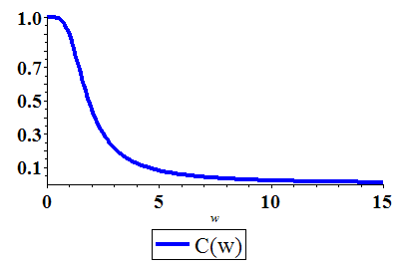





 starts with  and steadily decreases as *ω* increases.

Hence, there is no practical resonance frequency.

***Exercise***

A forced mass−spring−dashpot system with equation . Investigate the possibility of practical resonance of this system. In particular, find the amplitude  of steady state periodic forced oscillations with frequency *ω*. Sketch the graph  of and find the practical resonance frequency *ω* (if any). 

***Solution***

 

 

 

 

 starts with  and steadily decreases as *ω* increases.

Hence there is no practical resonance frequency.

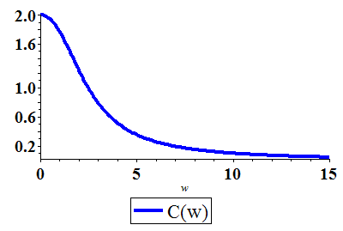

***Exercise***

A forced mass−spring−dashpot system with equation . Investigate the possibility of practical resonance of this system. In particular, find the amplitude  of steady state periodic forced oscillations with frequency *ω*. Sketch the graph  of and find the practical resonance frequency *ω* (if any). 

***Solution***

 

 

 

 

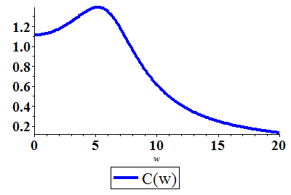



 (*C.N*)

 starts with , hence the practical resonance frequency is .

***Exercise***

A forced mass−spring−dashpot system with equation . Investigate the possibility of practical resonance of this system. In particular, find the amplitude  of steady state periodic forced oscillations with frequency *ω*. Sketch the graph  of and find the practical resonance frequency *ω* (if any). 

***Solution***

 

 

 

 

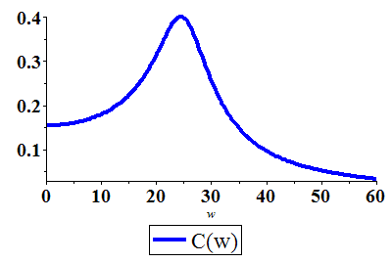



 (*C.N*)

 starts with , hence the practical resonance frequency is .

***Exercise***

A mass weighing 100 *lb*. (mass *m* = 3.125 *slugs* in *fps* units) is attached to the end of a spring that is stretched 1 *in*. by a force of 100 *lb*. A force  acts on the mass. At what frequency (in hertz) will resonance oscillation occur? Neglect damping.

***Solution***

***Given***: *m* = 3.125 *slug*











***Exercise***

A mass weighing 16 *pounds* stretches a spring . The mass is initially released form rest from a point  below the equilibrium position, and the subsequent motion takes place in a medium that offers a damping force that is numerically equal to  the instantaneous velocity. Find the equation of motion if the mass is driven by an external force equal to 

***Solution***



 

 

































***Exercise***

A mass of 32 *pounds* is attached to a spring with a constant spring . Initially, the mass is released 1 *foot* below the equilibrium position with a downward velocity of , and the subsequent motion takes is numerically equal to 2 times the instantaneous velocity.

1. Find the equation of motion if the mass is driven by an external force equal to .
2. Graph the transient, steady-state, and the equation of motion solutions on the same coordinate axes.

***Solution***



1.  





























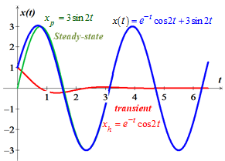

***Exercise***

A mass of 32 *pounds* is attached to a spring and stretched it 2 *feet* and then comes to rest in the equilibrium position. The surrounding medium offers a damping force that is numerically equal to 8 times the instantaneous velocity

1. Find the equation of motion if the mass is driven by an external force equal to .
2. Graph the transient, steady-state, and the equation of motion solutions on the same coordinate axes.

***Solution***

***Given***:  

 

1.  



 (***Transient solution***)











 (***Steady-state solution***)











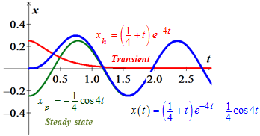

***Exercise***

A mass of 32 *pounds* is attached to a spring and stretched it 2 *feet* and then comes to rest in the equilibrium position. The surrounding medium offers a damping force that is numerically equal to 8 times the instantaneous velocity

1. Find the equation of motion with a starting external force equal to  at 
2. Graph the transient, steady-state, and the equation of motion solutions on the same coordinate axes.

***Solution***

***Given***:  

 

1.  



 (***Transient solution***)

















 (***Steady-state solution***)











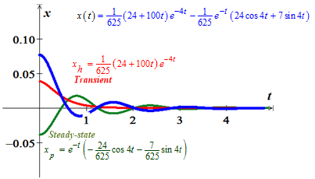

***Exercise***

A mass of 64 *pounds* is attached to a spring with a spring constant  and then comes to rest in the equilibrium position. Neglect the damping.

1. Find the equation of motion with a starting external force equal to  at 
2. Graph the transient, steady-state, and the equation of motion solutions on the same coordinate axes.

***Solution***

***Given***: 

1.  



 (***Transient solution***)















 (***Steady-state solution***)











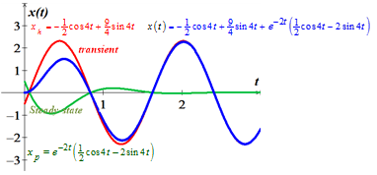

***Exercise***

A 3-*kg* object is attached to a spring and stretches the spring 392 *mm* by itself. There is no damping in the system and a forcing function of the form  is attached to the object and the system will experience resonance. If the object is initially displaced 20 *cm* downward from its equilibrium position and given a velocity of  upward find the displacement  at any time *t*.

***Solution***

 



 

















 













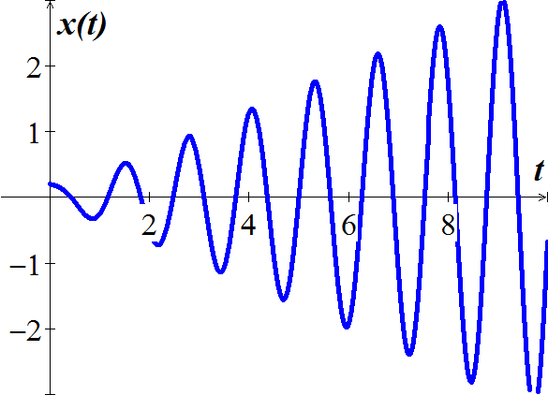

***Exercise***

A  mass is attached to a spring hanging vertically, thereby causing the spring to stretch 1.96 *m* upon coming to rest at equilibrium. The damping constant is given by .

1. Find the equation of motion if the mass is driven by an external force equal to  at  .
2. Determine the transient, steady-state solution of the motion

***Solution***

***Given***: 

1.  































1. *Transient* solution: 

*Steady-state* solution: 

***Exercise***

A  mass is attached to a spring hanging vertically, thereby causing the spring to stretch 0.2 *m* upon coming to rest at equilibrium. At , the mass is displaced 5 *cm* below the equilibrium position and released. The damping constant is given by .

1. Find the equation of motion if the mass is driven by an external force equal to .
2. Determine the transient, steady-state solution of the motion.

***Solution***

***Given***: 

1.  































1. *Transient* solution: 

*Steady-state* solution: 

***Exercise***

A  mass is attached to a spring hanging vertically and come to rest at equilibrium. The damping constant is given by  and the spring constant is . Find steady-state solution if the mass is driven by an external force equal to .

***Solution***

***Given***: 

 























*Steady-state* solution: 

***Exercise***

A  mass weight is attached to a spring hanging vertically and come to rest at equilibrium. The damping constant is given by  and the spring constant is . If the mass is driven by an external force equal to  at time .

1. Find steady-state solution.
2. Determine the amplitude and frequency

***Solution***

***Given***: 

1.  





















1. *Amplitude*: 



*Frequency*: 

***Exercise***

A  mass is attached to a spring hanging vertically and come to rest at equilibrium. The damping constant is given by  and the spring constant is . If the mass is driven by an external force equal to .

1. Find steady-state solution.
2. Determine the amplitude, phase angle, period and frequency

***Solution***

***Given***: 

1.  























1. *Amplitude*: 

*Phase angle*: 

*Period*:

*Frequency*: 



***Exercise***

A  mass is attached to a spring hanging vertically stretches the spring  from its equilibrium rest position, measured positive in the downward direction. At time , the resulting spring-mass system is disturbed from its rest state by the force . (*t* in *seconds*)

1. Determine the spring constant *k*.
2. Find the equation of motion.
3. Plot the equation of motion.
4. Determine the maximum excursion from equilibrium made of the object on the *t*-interval 

***Solution***

1.  



1.  

















 













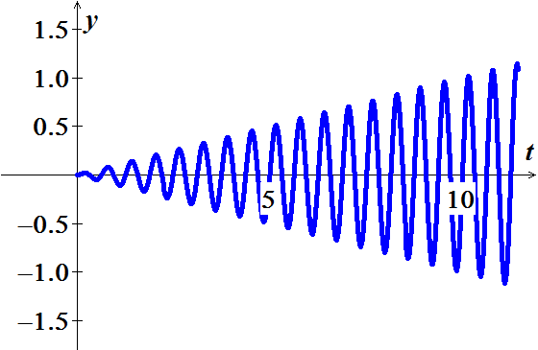

1. There is no maximum excursion.

***Exercise***

A  mass is attached to a spring hanging vertically stretches the spring  from its equilibrium rest position, measured positive in the downward direction. At time , the resulting spring-mass system is disturbed from its rest state by the force . (*t* in *seconds*)

1. Determine the spring constant *k*.
2. Find the equation of motion.
3. Plot the equation of motion.
4. Determine the maximum excursion from equilibrium made of the object on the *t*-interval 

***Solution***

1.  
2.  













 













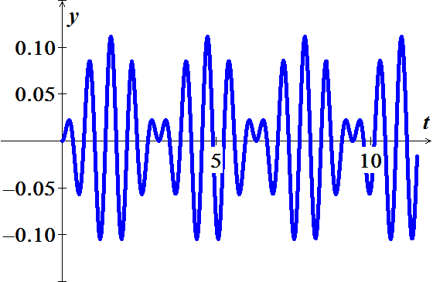

1.  







1.568 0.11108

1.570 0.11111

1.572 0.11110

***Exercise***

A  mass is attached to a spring hanging vertically stretches the spring  from its equilibrium rest position, measured positive in the downward direction. At time , the resulting spring-mass system is disturbed from its rest state by the force . (*t* in *seconds*)

1. Determine the spring constant *k*.
2. Find the equation of motion.
3. Plot the equation of motion.
4. Determine the maximum excursion from equilibrium made of the object on the *t*-interval 

***Solution***

1.  
2.  





























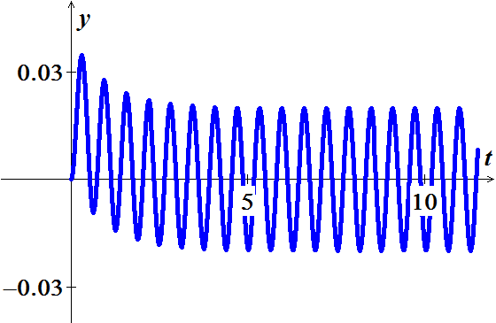

1. 

0.29320 0.03455

0.29440 0.03456

0.29560 0.03456

0.29680 0.03456

0.29800 0.03456

0.29920 0.03456

0.30040 0.03455

***Exercise***

A  mass is attached to a spring hanging vertically and come to rest at equilibrium. The damping constant is given by  and the spring constant is . At time , the resulting spring-mass system is disturbed from its rest state by the force . (*t* in *seconds*)

1. Find the equation of motion.
2. Plot the equation of motion.
3. Determine the long-time behavior of the system, as 

***Solution***

1.  































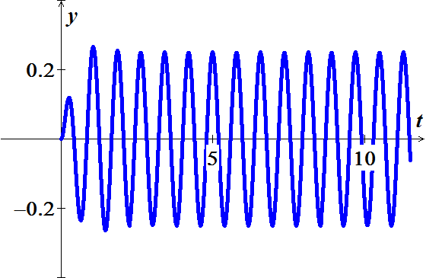

1. 



The equation of motion is a steady-state solution.

***Exercise***

A  mass is attached to a spring hanging vertically and come to rest at equilibrium. The damping constant is given by  and the spring constant is . At time , the resulting spring-mass system is disturbed from its rest state by the force . (*t* in *seconds*)

1. Find the equation of motion.
2. Plot the equation of motion.
3. Determine the long-time behavior of the system, as 

***Solution***

1.  

































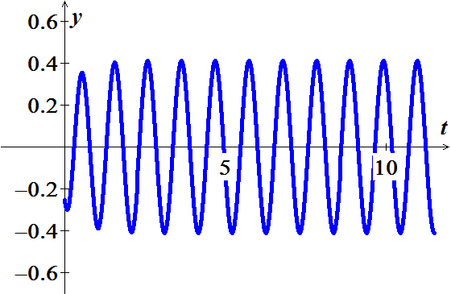

1. 



The equation of motion is a steady-state solution.

***Exercise***

A  mass is attached to a spring hanging vertically and come to rest at equilibrium. The damping constant is given by  and the spring constant is . At time , the resulting spring-mass system is disturbed from its rest state by the force . (*t* in *seconds*)

1. Find the equation of motion.
2. Plot the equation of motion.
3. Determine the long-time behavior of the system, as 

***Solution***

1.  



























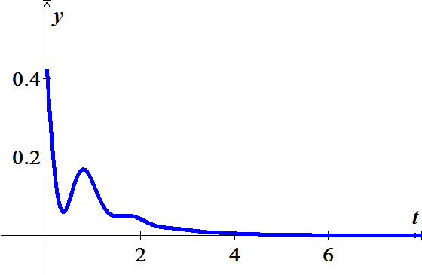

1. 

***Exercise***

A  mass is attached to a spring having a spring constant of . The mass is started in motion initially from the equilibrium position with an initial velocity  in the upward direction and with an applied external force . If the force due to air resistance is .

1. Find the equation motion of the mass.
2. Plot the motion
3. Determine the motion of the solution.

***Solution***

1. 















 























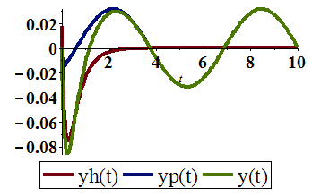 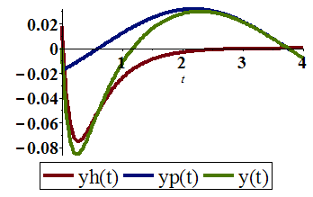

1. 

The homogeneous equation  are transient part of the solution which quickly die out.

They are steady-state part of the solution.

***Exercise***

A  weight is attached to a spring having a spring constant of . The weight is started in motion initially by displacing it  above the equilibrium position with no initial velocity and with an applied external force . Assume no air resistance.

1. Find the equation motion of the mass.
2. Plot the motion.
3. Determine the motion of the solution.

***Solution***

1. 





































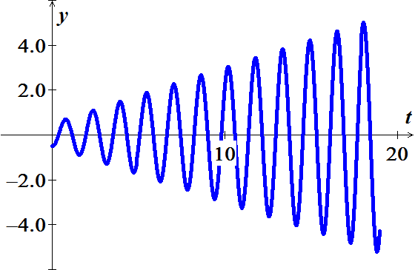

1. 

This is a pure resonance,

***Exercise***

A  object is attached to spring and stretches the spring  by itself. There is no damping in the system and a forcing function is given by  is attached to the object and the system will experience resonance. If the object is initially displaced  downward from its equilibrium position and given a velocity of upward.

1. Find the spring constant *k*.
2. Find the natural frequency *ω*.
3. Find the displacement at any time *t*.
4. Sketch the displacement function.

***Solution***

1.  
2.  
3. 

































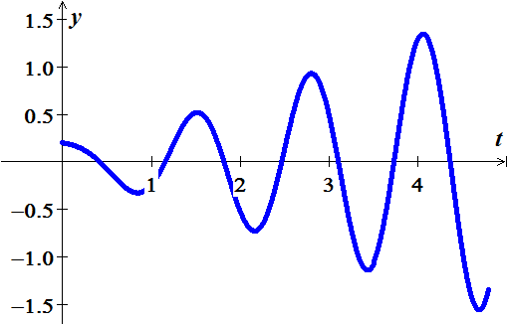

***Exercise***

Find the transient motion and steady periodic oscillations of a damped mass-and-spring system with , , and  under the influence of an external force  with  and . Also investigate the possibility of practical resonance for this system.

***Solution***

***Given***: , , , and  ; 

 

 















 





 













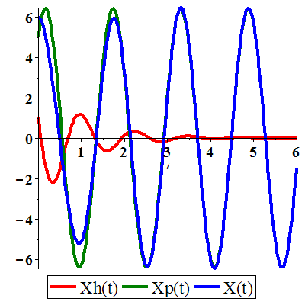

The forced amplitude at frequency *ω* is:







The mass-and-spring’s undamped critical frequency of 

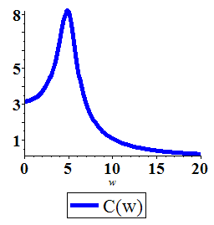

***Exercise***

A mass *m* is attached to the end of a spring with a spring constant *k*. After the mass reaches equilibrium, its support begins to oscillate vertically about a horizontal line *L* according to a formula . The value of *h* represents the distance in feet measured from *L*.

1. Determine the differential equation of motion if the entire system moves through a medium offering a damping force that is numerically equal to 
2. Solve the differential equation in part (a) if the spring is stretched 4 *feet* by a mass weighing 16 *pounds* and 

***Solution***

1. The external force is 

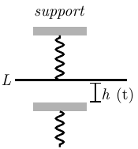 

1. ***Given***: 



































***Exercise***

A mass *m* on the end of a pendulum (of length *L*) also attached to a horizontal spring (with constant *k*). Assume small oscillations of *m* so that the spring remains essentially horizontal and neglect damping. Find the natural circular frequency  of motion of the mass in terms of *L, k, m*, and the gravitational constant *g*.

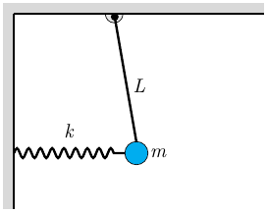***Solution***

Let *θ* is the angular displacement.

The displacement of the mass is: 

Its total energy  is

















***Exercise***

A mass *m* hangs on the end of a cord around a pullet of radius *a* and moment of inertia *I*. The rim of the pulley is attached to a spring (with constant *k*). Assume small oscillations so that the spring remains essentially and neglect friction. Find the natural circular frequency in terms of *m, a, k, I*, and *g*.

***Solution***

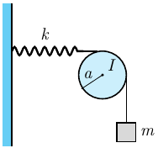Let *x* be the displacement of the mass from its equilibrium position.

 be the velocity.

 the angular velocity of the pulley.

 Conservation of energy













***Exercise***

Consider a floating cylindrical buoy with radius *r*, height *h*, and uniform density  (recall that the density of water is ). The buoy is initially suspended at rest with its bottom at the top surface of the water and is released at time . Therafter it is acted on by two forces: a downward gravitational force equal to its weight  and (by Archmedes’ principle of buoyancy) an upward force equal to the wieght  of water displaced, where  is the depth of the bottom of the buoy beneath the surface at time *t*.

Conclude that the buoy undergoes simple harmonic motion around its equilibrium position  with period .

1. Compute *p* and the amplitude of the motion if , , and 
2. If the cylindrical buoy weighting 100 *lb* floats in water with its axis vertical. When depressed slightly and released, it oscillates up and down four times every 10 *sec*. assume that friction is negligible. Find the radius of the buoy.

***Solution***

1. 



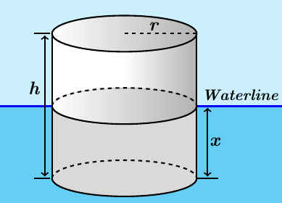









 











Amplitude: 

Period: 

1. ***Given***: 

The weight of water: 

 









***Exercise***

Assume that the earth is a solid sphere of uniform density, with mass *M* and radius *R* = 3960 (*mi*). For a particle of mass *m* within the earth at distance *r* from the center of the earth, the gravitational force attracting *m* toward the center is , where  is the mass of the part of the earth within a sphere of radius *r*.

1. Show that 
2. Now suppose that a small hole is drilled straight through the center of the earth, thus connecting two antipodal points on its surface. Let a particle of mass *m* be dropped at time  into this hole with initial speed zero, and let  be its distance from the center of the earth at time *t*. conclude from Newton’s second law and part (*a*) that , where .
3. Take , and conclude from part (*b*) that the particle undergoes simple harmonic motion back and forth between the ends of the hole, with a period of about 84 *min*.
4. Look up (or derive) the period of a satellite that just skims the surface of the earth; compare with the result in part (*c*). How do you explain the coincidence? Or is it a coincidence?
5. With what speed (in miles per hours) does the particle pass through the center of the earth?
6. Look up (or derive) the orbital velocity of a satellite that just skims the surface of the earth; compare with the result in part (*e*). How do you explain the coincidence? Or is it a coincidence?

***Solution***

1. 







1. Since 







1. 



 







***Given***: 

The period of the particle’s simple harmonic motion is:









1. The orbital velocity *v* of such a satellite must be such that the centrifugal force  on the satellite just offsets the weight *mg* of the satellite at the surface of the earth. Thus









Because the circumference of the earth is , the period of the satellite’s orbit is







Let assume that at time , the satellite is directly over the hole in the earth at the top, and its orbit proceeds in a clockwise direction.

The distance *r* of the particle, from part (*c*), from the center of the earth is



The key observation is that  is the angle drawn clockwise from the vertical to the radius vector of the satellite at time *t*; thus, the distance  is simply the vertical component of the satellite’s position. It follows that  completes one cycle through the earth (and back) in the same length of time required for the satellite to complete one orbit around the earth.

1. The particle passes through the center of the earth when , that is when .

At this time the speed of the particle is











1. The orbital velocity is .

The vertical component of the satellite’s velocity vector  at any given time *t* is equal to the speed  of the particle at that time.

At the moment when the particle passes through the center of earth, the satellite is travelling straight downward, and hence  is vertical.

Therefore, the orbital velocity *v* of the satellite, which is the magnitude of , is equal to the speed of the particle at this moment.

***Exercise***

Express the given circuit in the second-order differential equation

***Solution***

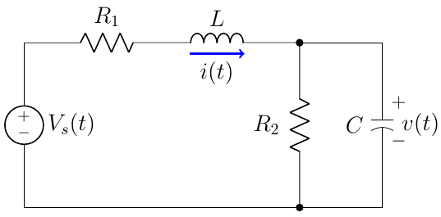











***Exercise***

Express the given circuit in the second-order differential equation

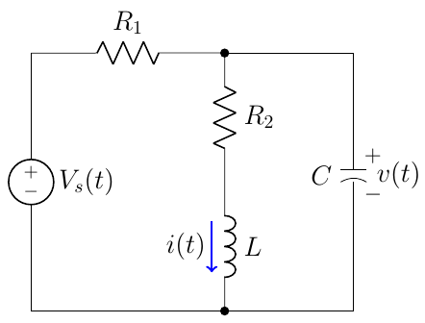***Solution***







 







***Exercise***

Find the steady-state solution  and the steady-state current in and *LRC*−series circuit when the source voltage is 

***Solution***





















Therefore, the steady-state charge is:



The steady-state current is: 



***Exercise***

Find the charge  on the capacitor in an *LRC*−series circuit when , , , , , and . Find the maximum charge on the capacitor

***Solution***

 



























Maximum charge: 







***Exercise***

Find the charge  on the capacitor in an *LRC*−series circuit when , , , , , and . Find the maximum charge on the capacitor

***Solution***

 



























Maximum charge: 







***Exercise***

Find the charge  and  on the capacitor in an *LRC*−series circuit when , , , and , , and . What is the charge on the capacitor after a long time?

***Solution***

 































***Exercise***

Find the charge  and  on the capacitor in an *LRC*−series circuit when , , , , , and .

***Solution***

 



























***Exercise***

Find the steady-state charge and the steady-state current in an *LRC*−series circuit when , , , and .

***Solution***

 





















The steady-state charge is: 

The steady-state current is: 

***Exercise***

Find the steady-state charge and the steady-state current in an *LRC*−series circuit when , , , and .

***Solution***

 





















The steady-state charge is: 

The steady-state current is: 

***Exercise***

Find the steady-state charge and the steady-state current in an *LRC*−series circuit when , , , and .

***Solution***

 



























The steady-state charge is: 

The steady-state current is: 

***Exercise***

Find the charge  and  on the capacitor in an *LC*−series circuit when



***Solution***

 































***Exercise***

Find the charge  and  on the capacitor in an *LC*−series circuit when



***Solution***

 





























***Exercise***

Find the charge  and  on the capacitor in an *LC*−series circuit when



***Solution***

 

































***Exercise***

Find the charge  and  on the capacitor in an *LC*−series circuit when



***Solution***

 





























***Exercise***

Find the charge  and  on the capacitor in an *LC*−series circuit when



***Solution***

 





























***Exercise***

Consider the parallel *RLC* network. Assume that at time , the voltage  and its time rate of change are both zero. Determine the voltage  for

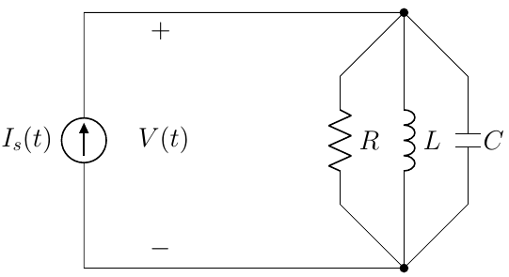 

***Solution***







































***Exercise***

Consider the parallel *RLC* network. Assume that at time , the voltage  and its time rate of change are both zero. Determine the voltage  for



***Solution***

























 

















***Exercise***

Consider the parallel *RLC* network. Assume that at time , the voltage  and its time rate of change are both zero. Determine the voltage  for



***Solution***

























 

















***Exercise***

Consider the parallel *RLC* network. Assume that at time , the voltage  and its time rate of change are both zero. Determine the voltage  for



***Solution***







































***Exercise***

An *RCL* circuit connected in series has , and applied voltage . Assuming no initial charge on the capacitor, but an initial current of  at  when the voltage is first applied.

1. Find the subsequent charge on the capacitor.
2. Plot the *transient*, *steady-state*, and the charge on the capacitor.
3. Find the current on the capacitor.

***Solution***

1.  















 





















The solution is the sum of *transient* and *steady-state* terms

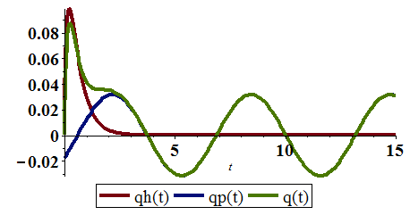

1. 

***Exercise***

An *RCL* circuit connected in series has , and applied voltage . Assuming no initial charge and no initial current at  when the voltage is first applied.

1. Find the subsequent charge on the capacitor.
2. Plot the *transient*, *steady-state*, and the charge on the capacitor.
3. Find the current on the capacitor.

***Solution***

1.  



























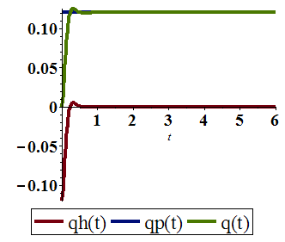

1. 



∴ This is a completely transient

***Exercise***

An *RCL* circuit connected in series has , and applied voltage . Assuming no initial charge and no initial current at  when the voltage is first applied.

1. Find the subsequent charge on the capacitor.
2. Plot the *transient*, *steady-state*, and the charge on the capacitor.
3. Find the current flowing through this circuit.

***Solution***

1.  















 

















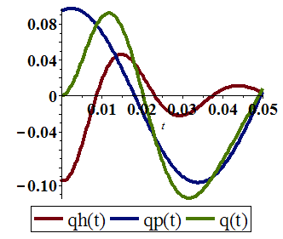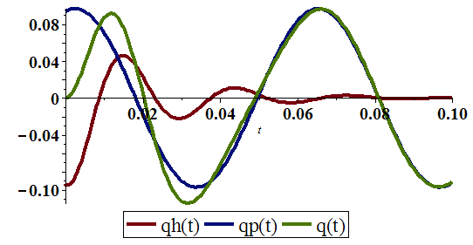





***Exercise***

An *RCL* circuit connected in series has , and applied voltage . Assuming no initial charge and no initial current at  when the voltage is first applied.

1. Find the charge in the circuit at time *t*.
2. Find the current flowing through this circuit.
3. Find the linit of the charge as 

***Solution***

1.  



































1. 





1. 

 : is *steady state* solution



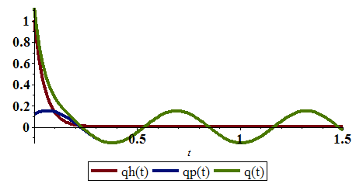

***Exercise***

A series circuit consists of a resistor with , an inductor with , a capacitor with , and a 12-*V* battery. If the initial charge and current are both 0, find the charge and current at time *t*.

***Solution***

 































***Exercise***

A series circuit consists of a resistor with , an inductor with , a capacitor with , and  . If the initial charge and current are both 0, find the charge and current at time *t*.

***Solution***

 















 





















***Exercise***

Consider the given circuit. Assuming that the voltage source changes from 10 to 25 *V* at time , , where  is a unit step function.

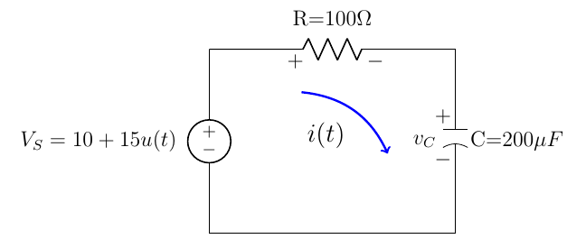

Find the expressions that describe the voltage drop across the resistor across the capacitor and the current in the loop for 

***Solution***

***Given***: 



Applying Kirkoff Voltage law: 





 



 







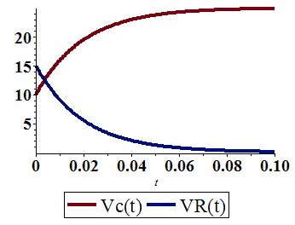 









***Exercise***

Find the steady-state solution  and the steady-state current in and *LRC*−series circuit when the source voltage is 

***Solution***



























Therefore, the steady-state charge is:



The steady-state current is: 



***Exercise***

Consider the given *RC*-circuit with impressed *emf* is . If no initial current is flowing at , find the current  for all .

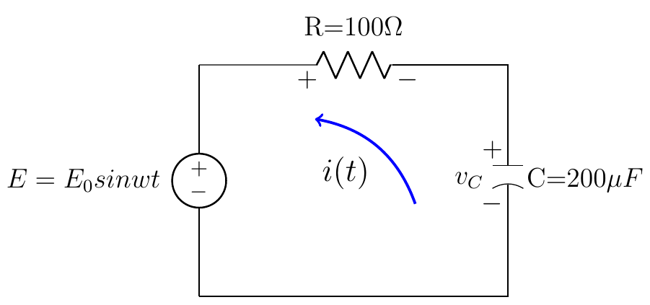

***Solution***

***Given***: 





 







|  |  |  |
| --- | --- | --- |
|  |  |  |
| **+** |  |  |
| **−** |  |  |
| **+** |  |  |





















***Solution******Section* 2.7 − Euler's & Runge-Kutta Methods**

***Exercise***

Calculate the first five iterations of Euler's method with step  of



***Solution***

|  |  |
| --- | --- |
| *t* | *y* |
| 0.1 | 1.00000000 |
| 0.2 | 1.01000000 |
| 0.3 | 1.03020000 |
| 0.4 | 1.06110600 |
| 0.5 | 1.10355024 |













***Exercise***

Calculate the first five iterations of Euler's method with step  of



***Solution***

|  |  |
| --- | --- |
| *x* | *z* |
| 0.0 | 1.00000000 |
| 0.1 | 0.80000000 |
| 0.2 | 0. 65000000 |
| 0.3 | 0.54000000 |
| 0.4 | 0.46200000 |
| 0.5 | 0.40960000 |

***Exercise***

Calculate the first five iterations of Euler's method with step  of: 

***Solution***



The *first* step:





The *second* step:





***Euler Method***

***t Approx. Exact Difference***

----------------------------------------------------------------

0.00 | 0.00000000 | 0.00000000 | 0.00000000

0.10 | 0.50000000 | 0.47581291 | -0.02418709

0.20 | 0.95000000 | 0.90634623 | -0.04365377

0.30 | 1.35500000 | 1.29590890 | -0.05909110

0.40 | 1.71950000 | 1.64839977 | -0.07110023

0.50 | 2.04755000 | 1.96734670 | -0.08020330



***Exercise***

Given: 

1. Use a computer and Euler's method to calculate three separate approximate solutions on the interval , one with step size , a second with step size , a second with step size .
2. Use the appropriate analytic to compute the exact solution
3. Plot the exact solution and approximate solutions as discrete points.

***Solution***

|  |  |
| --- | --- |
| *x* | *y* |
| 0.0 | 8.00000000 |
| 0.2 | 8.00000000 |
| 0.4 | 7.40000000 |
| 0.6 | 6.29600000 |
| 0.8 | 4.90496000 |
| 1.0 | 3.49537280 |
| *x* | *y* |
| 0.0 | 8.00000000 |
| 0.1 | 8.00000000 |
| 0.2 | 7.85000000 |
| 0.3 | 7.55600000 |
| 0.4 | 7.13264000 |
| 0.5 | 6.60202880 |
| 0.6 | 5.99182592 |
| 0.7 | 5.33280681 |
| 0.8 | 4.65621386 |
| 0.9 | 3.99121964 |
| 1.0 | 3.36280010 |

|  |  |  |  |
| --- | --- | --- | --- |
| *x* | *y* | *x* | *y* |
| 0.0 | 8.00000000 |  |  |
| 0.05 | 8.00000000 | 0.55 | 6.16870319 |
| 0.10 | 7.96250000 | 0.60 | 5.85692451 |
| 0.15 | 7.88787500 | 0.65 | 5.53550904 |
| 0.20 | 7.77705688 | 0.70 | 5.20820096 |
| 0.25 | 7.63151574 | 0.75 | 4.87862689 |
| 0.30 | 7.45322784 | 0.80 | 4.55022987 |
| 0.35 | 7.24463101 | 0.85 | 4.22621148 |
| 0.40 | 7.00856892 | 0.90 | 3.90948351 |
| 0.45 | 6.74822617 | 0.95 | 3.60262999 |
| 0.50 | 6.46705599 | 1.00 | 3.30788014 |



***t Approx. Exact Difference***

--------------------------------------------------------

0.00 | 8.00000000 | 8.00000000 | 0.00000000

0.20 | 8.00000000 | 7.70592079 | -0.29407921

0.40 | 7.40000000 | 6.89107842 | -0.50892158

0.60 | 6.29600000 | 5.73257245 | -0.56342755

0.80 | 4.90496000 | 4.45469318 | -0.45026682

1.00 | 3.49537280 | 3.25909581 | -0.23627699

***t Approx. Exact Difference***

--------------------------------------------------------

0.00 | 8.00000000 | 8.00000000 | 0.00000000

0.10 | 8.00000000 | 7.92537375 | -0.07462625

0.20 | 7.85000000 | 7.70592079 | -0.14407921

0.30 | 7.55600000 | 7.35448389 | -0.20151611

0.40 | 7.13264000 | 6.89107842 | -0.24156158

0.50 | 6.60202880 | 6.34100587 | -0.26102293

0.60 | 5.99182592 | 5.73257245 | -0.25925347

0.70 | 5.33280681 | 5.09469796 | -0.23810885

0.80 | 4.65621386 | 4.45469318 | -0.20152068

0.90 | 3.99121964 | 3.83643550 | -0.15478414

1.00 | 3.36280010 | 3.25909581 | -0.10370430

***t Approx. Exact Difference***

--------------------------------------------------------

0.00 | 8.00000000 | 8.00000000 | 0.00000000

0.05 | 8.00000000 | 7.98127342 | -0.01872658

0.10 | 7.96250000 | 7.92537375 | -0.03712625

0.15 | 7.88787500 | 7.83313428 | -0.05474072

0.20 | 7.77705688 | 7.70592079 | -0.07113608

0.25 | 7.63151574 | 7.54559797 | -0.08591777

0.30 | 7.45322784 | 7.35448389 | -0.09874395

0.35 | 7.24463101 | 7.13529429 | -0.10933672

0.40 | 7.00856892 | 6.89107842 | -0.11749051

0.45 | 6.74822617 | 6.62514862 | -0.12307755

0.50 | 6.46705599 | 6.34100587 | -0.12605012

0.55 | 6.16870319 | 6.04226366 | -0.12643953

0.60 | 5.85692451 | 5.73257245 | -0.12435207

0.65 | 5.53550904 | 5.41554691 | -0.11996214

0.70 | 5.20820096 | 5.09469796 | -0.11350300

0.75 | 4.87862689 | 4.77337119 | -0.10525570

0.80 | 4.55022987 | 4.45469318 | -0.09553669

0.85 | 4.22621148 | 4.14152671 | -0.08468477

0.90 | 3.90948351 | 3.83643550 | -0.07304801

0.95 | 3.60262999 | 3.54165879 | -0.06097120

1.00 | 3.30788014 | 3.25909581 | -0.04878433

***Exercise***

Given: 

1. Solve the differential equation
2. Use Euler's method and Runge-Kutta methods to calculate three separate approximate solutions on the interval , one with step size , a second with step size , a second with step size Plot the exact solution and approximate solutions as discrete points.

***Solution***

1. 











1. 

Euler Method

***t Approx. Exact Difference***

-----------------------------------------------------------------

0.00 | 1.00000000 | 1.00000000 | 0.00000000

0.20 | 0.80000000 | 0.88950446 | 0.08950446

0.40 | 0.79013421 | 0.87628378 | 0.08614957

0.60 | 0.83370122 | 0.89476187 | 0.06106065

0.80 | 0.88207714 | 0.91943284 | 0.03735570

1.00 | 0.92109384 | 0.94149018 | 0.02039633

Runge-Kutta 2nd Order

***t Approx. Exact Difference***

--------------------------------------------------------

0.00 | 1.00000000 | 1.00000000 | 0.00000000

0.20 | 0.89506710 | 0.88950446 | -0.00556264

0.40 | 0.88149624 | 0.87628378 | -0.00521246

0.60 | 0.89823186 | 0.89476187 | -0.00346999

0.80 | 0.92127837 | 0.91943284 | -0.00184552

1.00 | 0.94219199 | 0.94149018 | -0.00070181

Runge-Kutta 4th Order

***t Approx. Exact Difference***

--------------------------------------------------------

0.00 | 1.00000000 | 1.00000000 | 0.00000000

0.20 | 0.88960071 | 0.88950446 | -0.00009625

0.40 | 0.87638272 | 0.87628378 | -0.00009894

0.60 | 0.89483774 | 0.89476187 | -0.00007587

0.80 | 0.91948402 | 0.91943284 | -0.00005118

1.00 | 0.94152197 | 0.94149018 | -0.00003179

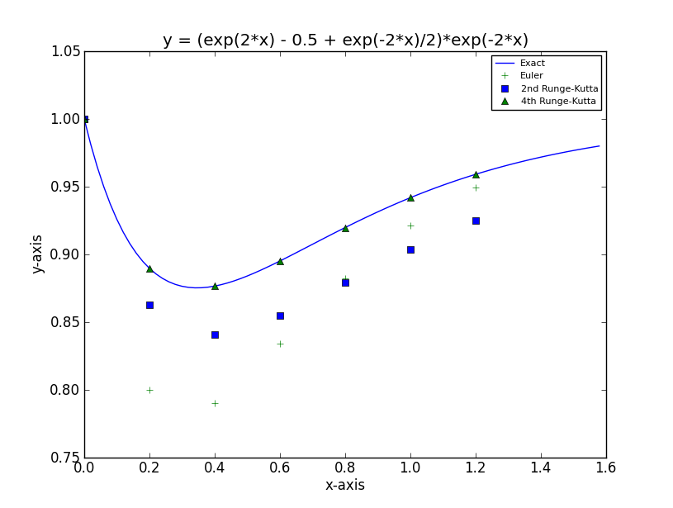



Euler Method

***t Approx. Exact Difference***

---------------------------------------------------------------

0.00 | 1.00000000 | 1.00000000 | 0.00000000

0.10 | 0.90000000 | 0.92579465 | 0.02579465

0.20 | 0.85296800 | 0.88950446 | 0.03653646

0.30 | 0.83744150 | 0.87619129 | 0.03874979

0.40 | 0.83983378 | 0.87628378 | 0.03645000

0.50 | 0.85167737 | 0.88372792 | 0.03205055

0.60 | 0.86780837 | 0.89476187 | 0.02695350

0.70 | 0.88517490 | 0.90710655 | 0.02193165

0.80 | 0.90205891 | 0.91943284 | 0.01737393

0.90 | 0.91757091 | 0.93101242 | 0.01344151

1.00 | 0.93132436 | 0.94149018 | 0.01016582

Runge-Kutta 2nd Order

***t Approx. Exact Difference***

----------------------------------------------------------------

0.00 | 1.00000000 | 1.00000000 | 0.00000000

0.10 | 0.92648400 | 0.92579465 | -0.00068935

0.20 | 0.89043763 | 0.88950446 | -0.00093317

0.30 | 0.87712599 | 0.87619129 | -0.00093470

0.40 | 0.87710071 | 0.87628378 | -0.00081694

0.50 | 0.88437996 | 0.88372792 | -0.00065204

0.60 | 0.89524226 | 0.89476187 | -0.00048039

0.70 | 0.90742943 | 0.90710655 | -0.00032288

0.80 | 0.91962162 | 0.91943284 | -0.00018878

0.90 | 0.93109305 | 0.93101242 | -0.00008064

1.00 | 0.94148757 | 0.94149018 | 0.00000260

Runge-Kutta 4th Order

***t Approx. Exact Difference***

----------------------------------------------------------------

0.00 | 1.00000000 | 1.00000000 | 0.00000000

0.10 | 0.92579791 | 0.92579465 | -0.00000326

0.20 | 0.88950913 | 0.88950446 | -0.00000467

0.30 | 0.87619629 | 0.87619129 | -0.00000500

0.40 | 0.87628854 | 0.87628378 | -0.00000476

0.50 | 0.88373216 | 0.88372792 | -0.00000424

0.60 | 0.89476548 | 0.89476187 | -0.00000361

0.70 | 0.90710953 | 0.90710655 | -0.00000298

0.80 | 0.91943524 | 0.91943284 | -0.00000240

0.90 | 0.93101431 | 0.93101242 | -0.00000189

1.00 | 0.94149164 | 0.94149018 | -0.00000146

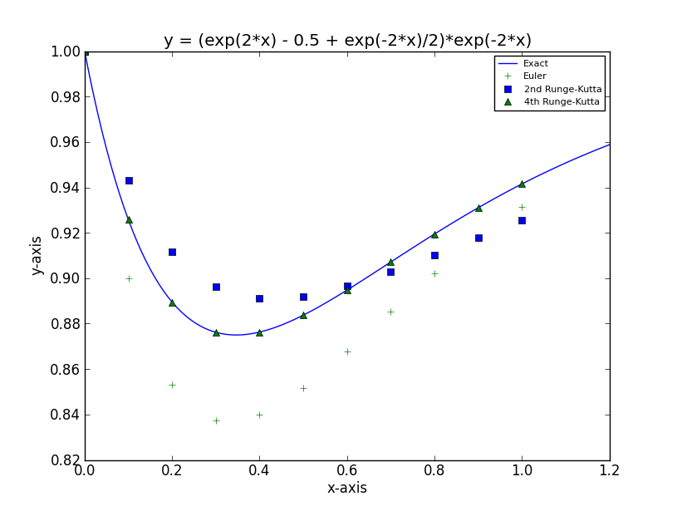



Euler Method

***t Approx. Exact Difference***

---------------------------------------------------------------

0.00 | 1.00000000 | 1.00000000 | 0.00000000

0.05 | 0.95000000 | 0.95694667 | 0.00694667

0.10 | 0.91406346 | 0.92579465 | 0.01173118

0.15 | 0.88914111 | 0.90399671 | 0.01485559

0.20 | 0.87278642 | 0.88950446 | 0.01671804

0.25 | 0.86304133 | 0.88067439 | 0.01763306

0.30 | 0.85834323 | 0.87619129 | 0.01784806

0.35 | 0.85744919 | 0.87500583 | 0.01755664

0.40 | 0.85937442 | 0.87628378 | 0.01690935

0.45 | 0.86334216 | 0.87936461 | 0.01602246

0.50 | 0.86874300 | 0.88372792 | 0.01498492

0.55 | 0.87510193 | 0.88896604 | 0.01386410

0.60 | 0.88205158 | 0.89476187 | 0.01271029

0.65 | 0.88931053 | 0.90087089 | 0.01156037

0.70 | 0.89666579 | 0.90710655 | 0.01044076

0.75 | 0.90395871 | 0.91332845 | 0.00936974

0.80 | 0.91107349 | 0.91943284 | 0.00835936

0.85 | 0.91792803 | 0.92534487 | 0.00741684

0.90 | 0.92446656 | 0.93101242 | 0.00654586

0.95 | 0.93065372 | 0.93640108 | 0.00574736

1.00 | 0.93646981 | 0.94149018 | 0.00502037

Runge-Kutta 2nd Order

***t Approx. Exact Difference***

---------------------------------------------------------------

0.00 | 1.00000000 | 1.00000000 | 0.00000000

0.05 | 0.95703173 | 0.95694667 | -0.00008506

0.10 | 0.92593427 | 0.92579465 | -0.00013963

0.15 | 0.90416803 | 0.90399671 | -0.00017132

0.20 | 0.88969058 | 0.88950446 | -0.00018612

0.25 | 0.88086308 | 0.88067439 | -0.00018869

0.30 | 0.87637395 | 0.87619129 | -0.00018266

0.35 | 0.87517663 | 0.87500583 | -0.00017080

0.40 | 0.87643901 | 0.87628378 | -0.00015523

0.45 | 0.87950216 | 0.87936461 | -0.00013754

0.50 | 0.88384684 | 0.88372792 | -0.00011892

0.55 | 0.88906627 | 0.88896604 | -0.00010023

0.60 | 0.89484396 | 0.89476187 | -0.00008208

0.65 | 0.90093579 | 0.90087089 | -0.00006489

0.70 | 0.90715548 | 0.90710655 | -0.00004893

0.75 | 0.91336281 | 0.91332845 | -0.00003435

0.80 | 0.91945408 | 0.91943284 | -0.00002123

0.85 | 0.92535446 | 0.92534487 | -0.00000958

0.90 | 0.93101179 | 0.93101242 | 0.00000063

0.95 | 0.93639162 | 0.93640108 | 0.00000946

1.00 | 0.94147318 | 0.94149018 | 0.00001700

Runge-Kutta 4th Order

***t Approx. Exact Difference***

---------------------------------------------------------------

0.00 | 1.00000000 | 1.00000000 | 0.00000000

0.05 | 0.95694677 | 0.95694667 | -0.00000011

0.10 | 0.92579483 | 0.92579465 | -0.00000018

0.15 | 0.90399694 | 0.90399671 | -0.00000023

0.20 | 0.88950472 | 0.88950446 | -0.00000026

0.25 | 0.88067466 | 0.88067439 | -0.00000027

0.30 | 0.87619156 | 0.87619129 | -0.00000027

0.35 | 0.87500610 | 0.87500583 | -0.00000027

0.40 | 0.87628404 | 0.87628378 | -0.00000026

0.45 | 0.87936486 | 0.87936461 | -0.00000025

0.50 | 0.88372815 | 0.88372792 | -0.00000023

0.55 | 0.88896625 | 0.88896604 | -0.00000021

0.60 | 0.89476207 | 0.89476187 | -0.00000020

0.65 | 0.90087107 | 0.90087089 | -0.00000018

0.70 | 0.90710671 | 0.90710655 | -0.00000016

0.75 | 0.91332860 | 0.91332845 | -0.00000015

0.80 | 0.91943297 | 0.91943284 | -0.00000013

0.85 | 0.92534499 | 0.92534487 | -0.00000011

0.90 | 0.93101252 | 0.93101242 | -0.00000010

0.95 | 0.93640117 | 0.93640108 | -0.00000009

1.00 | 0.94149026 | 0.94149018 | -0.00000008

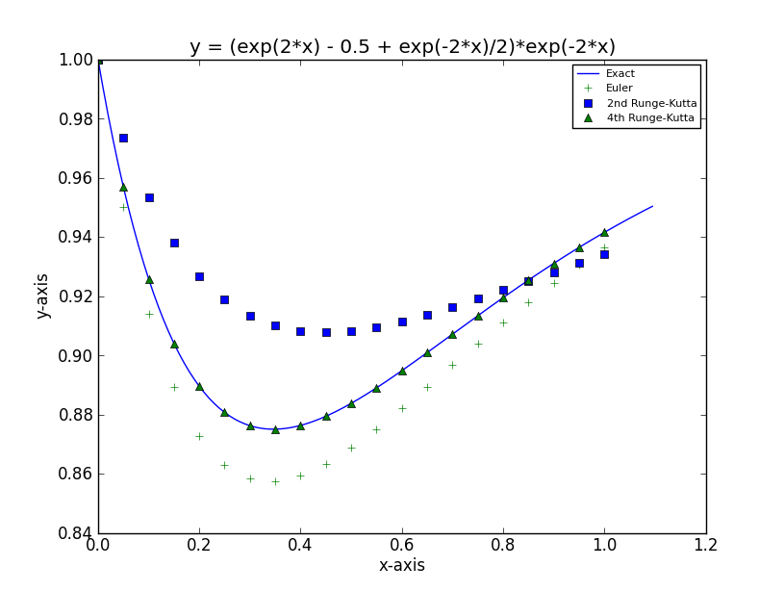

***Exercise***

Given: 

1. Use a computer and Euler's method to calculate three separate approximate solutions on the interval , one with step size , a second with step size , a third with step size .
2. Use the appropriate analytic to compute the exact solution
3. Plot the exact solution and approximate solutions as discrete points.

***Solution***

***a***)

***Euler Method***

***t Approx. Exact Difference***

--------------------------------------------------------

0.00 | 1.00000000 | 1.00000000 | 0.00000000

0.20 | 1.40000000 | 1.52166119 | 0.12166119

0.40 | 2.01967299 | 2.40358420 | 0.38391121

0.60 | 3.00558546 | 3.91773797 | 0.91215251

0.80 | 4.60623367 | 6.53800280 | 1.93176913

1.00 | 7.24121233 | 11.08358415 | 3.84237182

***Euler Method***

***t Approx. Exact Difference***

--------------------------------------------------------

0.00 | 1.00000000 | 1.00000000 | 0.00000000

0.10 | 1.20000000 | 1.22750977 | 0.02750977

0.20 | 1.45221403 | 1.52166119 | 0.06944716

0.30 | 1.77249333 | 1.90411415 | 0.13162082

0.40 | 2.18165556 | 2.40358420 | 0.22192865

0.50 | 2.70700830 | 3.05806706 | 0.35105875

0.60 | 3.38432406 | 3.91773797 | 0.53341391

0.70 | 4.26039588 | 5.04872396 | 0.78832807

0.80 | 5.39633906 | 6.53800280 | 1.14166374

0.90 | 6.87184946 | 8.49975469 | 1.62790522

1.00 | 8.79068763 | 11.08358415 | 2.29289652

***Euler Method***

***t Approx. Exact Difference***

--------------------------------------------------------

0.00 | 1.00000000 | 1.00000000 | 0.00000000

0.05 | 1.10000000 | 1.10655238 | 0.00655238

0.10 | 1.21276293 | 1.22750977 | 0.01474684

0.15 | 1.34014623 | 1.36504472 | 0.02489849

0.20 | 1.48428480 | 1.52166119 | 0.03737639

0.25 | 1.64763153 | 1.70024381 | 0.05261229

0.30 | 1.83300369 | 1.90411415 | 0.07111045

0.35 | 2.04363584 | 2.13709506 | 0.09345922

0.40 | 2.28324010 | 2.40358420 | 0.12034410

0.45 | 2.55607493 | 2.70863793 | 0.15256300

0.50 | 2.86702349 | 3.05806706 | 0.19104356

0.55 | 3.22168289 | 3.45854614 | 0.23686325

0.60 | 3.62646574 | 3.91773797 | 0.29127223

0.65 | 4.08871582 | 4.44443559 | 0.35571976

0.70 | 4.61683955 | 5.04872396 | 0.43188441

0.75 | 5.22045550 | 5.74216412 | 0.52170862

0.80 | 5.91056439 | 6.53800280 | 0.62743841

0.85 | 6.69974213 | 7.45141089 | 0.75166876

0.90 | 7.60235911 | 8.49975469 | 0.89739558

0.95 | 8.63482915 | 9.70290431 | 1.06807516

1.00 | 9.81589205 | 11.08358415 | 1.26769209

***b***) 















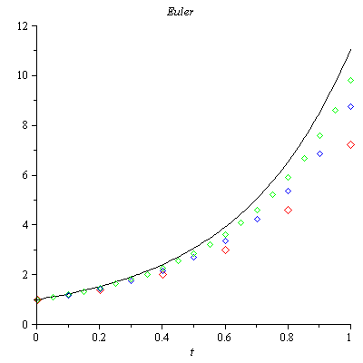

***Exercise***

Consider the initial value problem 

Use Euler's method with step size  to sketch solution on the interval 

***Solution***



***t Approx. Exact Difference***

--------------------------------------------------------

0.00 | 1.00000000 | 1.00000000 | 0.00000000

0.04 | 2.44000000 | 2.77812333 | 0.33812333

0.08 | 4.26707200 | 3.75770045 | -0.50937155

0.12 | 3.72005658 | 3.96254078 | 0.24248419

0.16 | 4.21993115 | 3.99446397 | -0.22546718

0.20 | 3.77444588 | 3.99918742 | 0.22474154

0.24 | 4.18308995 | 3.99988085 | -0.18320910

0.28 | 3.81546672 | 3.99998253 | 0.18451582

0.32 | 4.15342541 | 3.99999744 | -0.15342797

0.36 | 3.84754974 | 3.99999962 | 0.15244989

0.40 | 4.12909852 | 3.99999994 | -0.12909858

0.44 | 3.87322947 | 3.99999999 | 0.12677052

0.48 | 4.10891492 | 4.00000000 | -0.10891492

0.52 | 3.89410430 | 4.00000000 | 0.10589570

0.56 | 4.09204138 | 4.00000000 | -0.09204138

0.60 | 3.91125556 | 4.00000000 | 0.08874444

0.64 | 4.07786461 | 4.00000000 | -0.07786461

0.68 | 3.92545437 | 4.00000000 | 0.07454563

0.72 | 4.06591460 | 4.00000000 | -0.06591460

0.76 | 3.93727310 | 4.00000000 | 0.06272690

0.80 | 4.05582011 | 4.00000000 | -0.05582011

0.84 | 3.94714987 | 4.00000000 | 0.05285013

0.88 | 4.04728141 | 4.00000000 | -0.04728141

0.92 | 3.95542805 | 4.00000000 | 0.04457195

0.96 | 4.04005260 | 4.00000000 | -0.04005260

1.00 | 3.96238159 | 4.00000000 | 0.03761841

1.04 | 4.03392967 | 4.00000000 | -0.03392967

1.08 | 3.96823212 | 4.00000000 | 0.03176788

1.12 | 4.02874204 | 4.00000000 | -0.02874204

1.16 | 3.97316079 | 4.00000000 | 0.02683921

1.20 | 4.02434630 | 4.00000000 | -0.02434630

1.24 | 3.97731688 | 4.00000000 | 0.02268312

1.28 | 4.02062150 | 4.00000000 | -0.02062150

1.32 | 3.98082411 | 4.00000000 | 0.01917589

1.36 | 4.01746532 | 4.00000000 | -0.01746532

1.40 | 3.98378549 | 4.00000000 | 0.01621451

1.44 | 4.01479115 | 4.00000000 | -0.01479115

1.48 | 3.98628712 | 4.00000000 | 0.01371288

1.52 | 4.01252558 | 4.00000000 | -0.01252558

1.56 | 3.98840115 | 4.00000000 | 0.01159885

1.60 | 4.01060636 | 4.00000000 | -0.01060636

1.64 | 3.99018815 | 4.00000000 | 0.00981185

1.68 | 4.00898069 | 4.00000000 | -0.00898069

1.72 | 3.99169905 | 4.00000000 | 0.00830095

1.76 | 4.00760380 | 4.00000000 | -0.00760380

1.80 | 3.99297675 | 4.00000000 | 0.00702325

1.84 | 4.00643771 | 4.00000000 | -0.00643771

1.88 | 3.99405741 | 4.00000000 | 0.00594259

1.92 | 4.00545023 | 4.00000000 | -0.00545023

1.96 | 3.99497153 | 4.00000000 | 0.00502847

2.00 | 4.00461405 | 4.00000000 | -0.00461405

***Exercise***

You've seen that the error in Euler's method varies directly as the first power of the step size . This makes Euler's method an order to halve the error? How does this affect the number of required iterations?

***Solution***

Because  halving the step size should halve the error.



The number of iterations is given by: , therefore halving the step size should double the number of iterations.



***Exercise***

Use Euler’s method to provide an approximate solution over the given time interval using the given steps sizes. Provide a plot of ***v*** versus ***y*** for each step size



***Solution***

|  |  |
| --- | --- |
| ***h* = 0.1** | ***h* = 0.01** |

|  |  |
| --- | --- |
| ***h* = 0.001** |  |

***Exercise***



1. Use a computer and Runge-Kutta method to calculate three separate approximate solutions on the interval , one with step size , a second with step size , a second with step size .
2. Use the appropriate analytic to compute the exact solution
3. Plot the exact solution and approximate solutions as discrete points.

***Solution***



***Runge-Kutta* 2*nd Order***

t Approx. Exact Difference

--------------------------------------------------------

0.00 | 1.00000000 | 1.00000000 | 0.00000000

0.20 | 0.99800666 | 0.99873333 | 0.00072667

0.40 | 0.98887689 | 0.99039969 | 0.00152281

0.60 | 0.96709749 | 0.96939486 | 0.00229738

0.80 | 0.92871746 | 0.93169588 | 0.00297842

1.00 | 0.87131508 | 0.87482637 | 0.00351128

***Runge-Kutta* 4*th Order***

t Approx. Exact Difference

--------------------------------------------------------

0.00 | 1.00000000 | 1.00000000 | 0.00000000

0.20 | 0.99873272 | 0.99873333 | 0.00000061

0.40 | 0.99039822 | 0.99039969 | 0.00000147

0.60 | 0.96939245 | 0.96939486 | 0.00000241

0.80 | 0.93169258 | 0.93169588 | 0.00000330

1.00 | 0.87482232 | 0.87482637 | 0.00000405

***Runge-Kutta* 2*nd Order***

t Approx. Exact Difference

--------------------------------------------------------

0.00 | 1.00000000 | 1.00000000 | 0.00000000

0.10 | 0.99975021 | 0.99983750 | 0.00008729

0.20 | 0.99855245 | 0.99873333 | 0.00018088

0.30 | 0.99555979 | 0.99583746 | 0.00027767

0.40 | 0.99002480 | 0.99039969 | 0.00037489

0.50 | 0.98129932 | 0.98176938 | 0.00047006

0.60 | 0.96883388 | 0.96939486 | 0.00056098

0.70 | 0.95217687 | 0.95282259 | 0.00064572

0.80 | 0.93097330 | 0.93169588 | 0.00072258

0.90 | 0.90496314 | 0.90575327 | 0.00079013

1.00 | 0.87397921 | 0.87482637 | 0.00084716

***Runge-Kutta* 4*th Order***

t Approx. Exact Difference

--------------------------------------------------------

0.00 | 1.00000000 | 1.00000000 | 0.00000000

0.10 | 0.99983748 | 0.99983750 | 0.00000002

0.20 | 0.99873329 | 0.99873333 | 0.00000004

0.30 | 0.99583739 | 0.99583746 | 0.00000007

0.40 | 0.99039960 | 0.99039969 | 0.00000009

0.50 | 0.98176926 | 0.98176938 | 0.00000012

0.60 | 0.96939471 | 0.96939486 | 0.00000015

0.70 | 0.95282241 | 0.95282259 | 0.00000018

0.80 | 0.93169568 | 0.93169588 | 0.00000020

0.90 | 0.90575304 | 0.90575327 | 0.00000023

1.00 | 0.87482612 | 0.87482637 | 0.00000025

***Runge-Kutta* 2*nd Order***

t Approx. Exact Difference

--------------------------------------------------------

0.00 | 1.00000000 | 1.00000000 | 0.00000000

0.05 | 0.99996876 | 0.99997943 | 0.00001067

0.10 | 0.99981570 | 0.99983750 | 0.00002180

0.15 | 0.99942531 | 0.99945859 | 0.00003328

0.20 | 0.99868831 | 0.99873333 | 0.00004502

0.25 | 0.99750164 | 0.99755858 | 0.00005694

0.30 | 0.99576852 | 0.99583746 | 0.00006894

0.35 | 0.99339836 | 0.99347931 | 0.00008094

0.40 | 0.99030682 | 0.99039969 | 0.00009287

0.45 | 0.98641574 | 0.98652039 | 0.00010465

0.50 | 0.98165315 | 0.98176938 | 0.00011623

0.55 | 0.97595326 | 0.97608078 | 0.00012752

0.60 | 0.96925639 | 0.96939486 | 0.00013847

0.65 | 0.96150896 | 0.96165799 | 0.00014903

0.70 | 0.95266344 | 0.95282259 | 0.00015915

0.75 | 0.94267832 | 0.94284709 | 0.00016877

0.80 | 0.93151803 | 0.93169588 | 0.00017785

0.85 | 0.91915289 | 0.91933924 | 0.00018635

0.90 | 0.90555903 | 0.90575327 | 0.00019423

0.95 | 0.89071835 | 0.89091981 | 0.00020146

1.00 | 0.87461836 | 0.87482637 | 0.00020801

***Runge-Kutta* 4*th Order***

t y y(t) Difference

--------------------------------------------------------

0.00 | 1.00000000 | 1.00000000 | 0.00000000

0.05 | 0.99997943 | 0.99997943 | 0.00000000

0.10 | 0.99983750 | 0.99983750 | 0.00000000

0.15 | 0.99945859 | 0.99945859 | 0.00000000

0.20 | 0.99873333 | 0.99873333 | 0.00000000

0.25 | 0.99755858 | 0.99755858 | 0.00000000

0.30 | 0.99583745 | 0.99583746 | 0.00000000

0.35 | 0.99347930 | 0.99347931 | 0.00000001

0.40 | 0.99039969 | 0.99039969 | 0.00000001

0.45 | 0.98652039 | 0.98652039 | 0.00000001

0.50 | 0.98176937 | 0.98176938 | 0.00000001

0.55 | 0.97608077 | 0.97608078 | 0.00000001

0.60 | 0.96939485 | 0.96939486 | 0.00000001

0.65 | 0.96165798 | 0.96165799 | 0.00000001

0.70 | 0.95282258 | 0.95282259 | 0.00000001

0.75 | 0.94284708 | 0.94284709 | 0.00000001

0.80 | 0.93169587 | 0.93169588 | 0.00000001

0.85 | 0.91933923 | 0.91933924 | 0.00000001

0.90 | 0.90575325 | 0.90575327 | 0.00000001

0.95 | 0.89091979 | 0.89091981 | 0.00000001

1.00 | 0.87482635 | 0.87482637 | 0.00000002

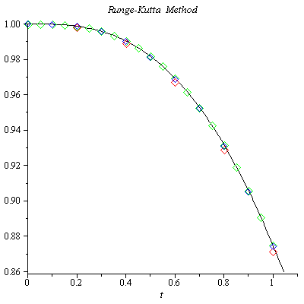

***Exercise***

Given 

1. Use a computer and Runge-Kutta method to calculate three separate approximate solutions on the interval , one with step size , a second with step size , a second with step size .
2. Use the appropriate analytic to compute the exact solution
3. Plot the exact solution and approximate solutions as discrete points.

***Solution***

***Runge-Kutta* 2*th Order***

***t Approx. Exact Difference***

--------------------------------------------------------

0.00 | 1.00000000 | 1.00000000 | 0.00000000

0.20 | 1.01961161 | 1.01980390 | 0.00019229

0.40 | 1.07636229 | 1.07703296 | 0.00067067

0.60 | 1.16495094 | 1.16619038 | 0.00123944

0.80 | 1.27887002 | 1.28062485 | 0.00175483

1.00 | 1.41205020 | 1.41421356 | 0.00216336

***Runge-Kutta* 4*th Order***

***t Approx. Exact Difference***

--------------------------------------------------------

0.00 | 1.00000000 | 1.00000000 | 0.00000000

0.20 | 1.01980437 | 1.01980390 | -0.00000046

0.40 | 1.07703431 | 1.07703296 | -0.00000135

0.60 | 1.16619234 | 1.16619038 | -0.00000196

0.80 | 1.28062701 | 1.28062485 | -0.00000216

1.00 | 1.41421570 | 1.41421356 | -0.00000214

***Runge-Kutta* 2*th Order***

***t Approx. Exact Difference***

--------------------------------------------------------

0.00 | 1.00000000 | 1.00000000 | 0.00000000

0.10 | 1.00497519 | 1.00498756 | 0.00001238

0.20 | 1.01975618 | 1.01980390 | 0.00004772

0.30 | 1.04392938 | 1.04403065 | 0.00010127

0.40 | 1.07686631 | 1.07703296 | 0.00016665

0.50 | 1.11779652 | 1.11803399 | 0.00023747

0.60 | 1.16588199 | 1.16619038 | 0.00030839

0.70 | 1.22027989 | 1.22065556 | 0.00037567

0.80 | 1.28018776 | 1.28062485 | 0.00043708

0.90 | 1.34487075 | 1.34536240 | 0.00049165

1.00 | 1.41367433 | 1.41421356 | 0.00053923

***Runge-Kutta* 4*th Order***

***t Approx. Exact Difference***

-----------------------------------------------------------

0.00 | 1.00000000 | 1.00000000 | 0.00000000

0.10 | 1.00498757 | 1.00498756 | -0.00000001

0.20 | 1.01980393 | 1.01980390 | -0.00000003

0.30 | 1.04403071 | 1.04403065 | -0.00000006

0.40 | 1.07703304 | 1.07703296 | -0.00000008

0.50 | 1.11803409 | 1.11803399 | -0.00000010

0.60 | 1.16619050 | 1.16619038 | -0.00000012

0.70 | 1.22065569 | 1.22065556 | -0.00000013

0.80 | 1.28062498 | 1.28062485 | -0.00000013

0.90 | 1.34536254 | 1.34536240 | -0.00000013

1.00 | 1.41421369 | 1.41421356 | -0.00000013

***Runge-Kutta* 2*th Order***

***t Approx. Exact Difference***

-----------------------------------------------------------

0.00 | 1.00000000 | 1.00000000 | 0.00000000

0.05 | 1.00124844 | 1.00124922 | 0.00000078

0.10 | 1.00498447 | 1.00498756 | 0.00000309

0.15 | 1.01118058 | 1.01118742 | 0.00000684

0.20 | 1.01979199 | 1.01980390 | 0.00001191

0.25 | 1.03075829 | 1.03077641 | 0.00001812

0.30 | 1.04400537 | 1.04403065 | 0.00002528

0.35 | 1.05944783 | 1.05948101 | 0.00003317

0.40 | 1.07699136 | 1.07703296 | 0.00004160

0.45 | 1.09653524 | 1.09658561 | 0.00005037

0.50 | 1.11797470 | 1.11803399 | 0.00005929

0.55 | 1.14120301 | 1.14127122 | 0.00006821

0.60 | 1.16611337 | 1.16619038 | 0.00007701

0.65 | 1.19260047 | 1.19268604 | 0.00008557

0.70 | 1.22056174 | 1.22065556 | 0.00009382

0.75 | 1.24989830 | 1.25000000 | 0.00010170

0.80 | 1.28051568 | 1.28062485 | 0.00010917

0.85 | 1.31232426 | 1.31244047 | 0.00011621

0.90 | 1.34523959 | 1.34536240 | 0.00012281

0.95 | 1.37918245 | 1.37931142 | 0.00012898

1.00 | 1.41407885 | 1.41421356 | 0.00013471

***Runge-Kutta* 4*th Order***

***t Approx. Exact Difference***

-----------------------------------------------------------

0.00 | 1.00000000 | 1.00000000 | 0.00000000

0.05 | 1.00124922 | 1.00124922 | -0.00000000

0.10 | 1.00498756 | 1.00498756 | -0.00000000

0.15 | 1.01118742 | 1.01118742 | -0.00000000

0.20 | 1.01980390 | 1.01980390 | -0.00000000

0.25 | 1.03077641 | 1.03077641 | -0.00000000

0.30 | 1.04403065 | 1.04403065 | -0.00000000

0.35 | 1.05948101 | 1.05948101 | -0.00000000

0.40 | 1.07703297 | 1.07703296 | -0.00000001

0.45 | 1.09658562 | 1.09658561 | -0.00000001

0.50 | 1.11803400 | 1.11803399 | -0.00000001

0.55 | 1.14127123 | 1.14127122 | -0.00000001

0.60 | 1.16619039 | 1.16619038 | -0.00000001

0.65 | 1.19268605 | 1.19268604 | -0.00000001

0.70 | 1.22065557 | 1.22065556 | -0.00000001

0.75 | 1.25000001 | 1.25000000 | -0.00000001

0.80 | 1.28062486 | 1.28062485 | -0.00000001

0.85 | 1.31244048 | 1.31244047 | -0.00000001

0.90 | 1.34536241 | 1.34536240 | -0.00000001

0.95 | 1.37931143 | 1.37931142 | -0.00000001

1.00 | 1.41421357 | 1.41421356 | -0.00000001

1. The equation is separable:

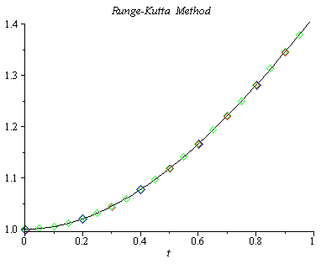



















***Exercise***

Consider the initial value problem 

Use Runge-Kutta method with step size  to sketch solution on the interval 

***Solution***



***Runge-Kutta* 4*th Order***

***t Approx. Exact Difference***

----------------------------------------------------------------

0.00 | 1.00000000 | 1.00000000 | 0.00000000

0.04 | 1.00079936 | 1.00079936 | -0.00000000

0.08 | 1.00318981 | 1.00318981 | -0.00000000

0.12 | 1.00714877 | 1.00714877 | -0.00000000

0.16 | 1.01263957 | 1.01263957 | -0.00000000

0.20 | 1.01961283 | 1.01961282 | -0.00000000

0.24 | 1.02800822 | 1.02800822 | -0.00000000

0.28 | 1.03775651 | 1.03775651 | -0.00000000

0.32 | 1.04878166 | 1.04878166 | -0.00000001

0.36 | 1.06100297 | 1.06100297 | -0.00000001

0.40 | 1.07433708 | 1.07433707 | -0.00000001

0.44 | 1.08869975 | 1.08869974 | -0.00000001

0.48 | 1.10400743 | 1.10400742 | -0.00000001

0.52 | 1.12017855 | 1.12017854 | -0.00000001

0.56 | 1.13713450 | 1.13713449 | -0.00000001

0.60 | 1.15480036 | 1.15480035 | -0.00000001

0.64 | 1.17310545 | 1.17310544 | -0.00000001

0.68 | 1.19198361 | 1.19198360 | -0.00000001

0.72 | 1.21137336 | 1.21137335 | -0.00000001

0.76 | 1.23121787 | 1.23121787 | -0.00000001

0.80 | 1.25146496 | 1.25146495 | -0.00000001

0.84 | 1.27206683 | 1.27206682 | -0.00000001

0.88 | 1.29297992 | 1.29297991 | -0.00000001

0.92 | 1.31416464 | 1.31416463 | -0.00000001

0.96 | 1.33558509 | 1.33558508 | -0.00000001

1.00 | 1.35720882 | 1.35720881 | -0.00000001

1.04 | 1.37900650 | 1.37900650 | -0.00000001

1.08 | 1.40095174 | 1.40095173 | -0.00000001

1.12 | 1.42302075 | 1.42302075 | -0.00000001

1.16 | 1.44519217 | 1.44519216 | -0.00000001

1.20 | 1.46744679 | 1.46744678 | -0.00000001

1.24 | 1.48976740 | 1.48976739 | -0.00000001

1.28 | 1.51213855 | 1.51213854 | -0.00000001

1.32 | 1.53454641 | 1.53454640 | -0.00000001

1.36 | 1.55697860 | 1.55697859 | -0.00000001

1.40 | 1.57942403 | 1.57942403 | -0.00000001

1.44 | 1.60187281 | 1.60187281 | -0.00000001

1.48 | 1.62431609 | 1.62431608 | -0.00000001

1.52 | 1.64674596 | 1.64674596 | -0.00000001

1.56 | 1.66915540 | 1.66915539 | -0.00000001

1.60 | 1.69153812 | 1.69153811 | -0.00000001

1.64 | 1.71388854 | 1.71388853 | -0.00000001

1.68 | 1.73620170 | 1.73620169 | -0.00000001

1.72 | 1.75847320 | 1.75847319 | -0.00000001

1.76 | 1.78069914 | 1.78069913 | -0.00000001

1.80 | 1.80287607 | 1.80287606 | -0.00000000

1.84 | 1.82500094 | 1.82500094 | -0.00000000

1.88 | 1.84707109 | 1.84707109 | -0.00000000

1.92 | 1.86908417 | 1.86908417 | -0.00000000

1.96 | 1.89103813 | 1.89103813 | -0.00000000

2.00 | 1.91293119 | 1.91293118 | -0.00000000

***Exercise***

Consider the initial value problem 

Use Runge-Kutta method with step size  to sketch solution on the interval 

***Solution***





|  |  |  |
| --- | --- | --- |
|  |  |  |
| **+** |  |  |
| **−** |  |  |
| **+** |  |  |

|  |  |  |
| --- | --- | --- |
|  |  |  |
| **+** |  |  |
| **−** |  |  |
| **+** |  |  |

























***Euler Method***

***t Approx. Exact Difference***

------------------------------------------------------------------

0.00 | 0.00000000 | 0.00000000 | 0.00000000

0.05 | 0.25000000 | 0.25366702 | 0.00366702

0.10 | 0.50451846 | 0.50400621 | -0.00051225

0.15 | 0.74778853 | 0.73472762 | -0.01306091

0.20 | 0.96397872 | 0.92996926 | -0.03400946

0.25 | 1.13821003 | 1.07534045 | -0.06286957

0.30 | 1.25756378 | 1.15892383 | -0.09863994

0.35 | 1.31201510 | 1.17216954 | -0.13984556

0.40 | 1.29522788 | 1.11061839 | -0.18460949

0.45 | 1.20515309 | 0.97439874 | -0.23075435

0.50 | 1.04438175 | 0.76845344 | -0.27592831

0.55 | 0.82021731 | 0.50246840 | -0.31774891

0.60 | 0.54444836 | 0.19049209 | -0.35395627

0.65 | 0.23282095 | -0.14974538 | -0.38256633

0.70 | -0.09577085 | -0.49778510 | -0.40201424

0.75 | -0.42033859 | -0.83161681 | -0.41127822

0.80 | -0.71904181 | -1.12901665 | -0.40997485

0.85 | -0.97054890 | -1.36896715 | -0.39841824

0.90 | -1.15543496 | -1.53307240 | -0.37763744

0.95 | -1.25752830 | -1.60687699 | -0.34934869

1.00 | -1.26511659 | -1.58099885 | -0.31588225

1.05 | -1.17192748 | -1.45199341 | -0.28006593

1.10 | -0.97780916 | -1.22287990 | -0.24507073

1.15 | -0.68905162 | -0.90327826 | -0.21422665

1.20 | -0.31830941 | -0.50912823 | -0.19081882

1.25 | 0.11588941 | -0.06198694 | -0.17787635

1.30 | 0.59003789 | 0.41207112 | -0.17796677

1.35 | 1.07691137 | 0.88390140 | -0.19300997

1.40 | 1.54713288 | 1.32300854 | -0.22412434

1.45 | 1.97095749 | 1.69944069 | -0.27151680

1.50 | 2.32017202 | 1.98574597 | -0.33442605

1.55 | 2.56999372 | 2.15886828 | -0.41112544

1.60 | 2.70084550 | 2.20185727 | -0.49898823

1.65 | 2.69988727 | 2.10527280 | -0.59461447

1.70 | 2.56219211 | 1.86817786 | -0.69401425

1.75 | 2.29147346 | 1.49863486 | -0.79283860

1.80 | 1.90029341 | 1.01364791 | -0.88664550

1.85 | 1.40971217 | 0.43852637 | -0.97118580

1.90 | 0.84837261 | -0.19431898 | -1.04269159

1.95 | 0.25104980 | -0.84709881 | -1.09814861

2.00 | -0.34326837 | -1.47880270 | -1.13553433

2.05 | -0.89366994 | -2.04767466 | -1.15400472

2.10 | -1.35984868 | -2.51386357 | -1.15401490

2.15 | -1.70472418 | -2.84208687 | -1.13736269

2.20 | -1.89698837 | -3.00413660 | -1.10714824

2.25 | -1.91341049 | -2.98105850 | -1.06764801

2.30 | -1.74073987 | -2.76484685 | -1.02410698

2.35 | -1.37706328 | -2.35952135 | -0.98245807

2.40 | -0.83250141 | -1.78148483 | -0.94898341

2.45 | -0.12916591 | -1.05910196 | -0.92993604

2.50 | 0.69965839 | -0.23148617 | -0.93114456

2.55 | 1.61109302 | 0.65346778 | -0.95762524

2.60 | 2.55494455 | 1.54171751 | -1.01322704

2.65 | 3.47657170 | 2.37623761 | -1.10033409

2.70 | 4.32018626 | 3.10053857 | -1.21964769

2.75 | 5.03239764 | 3.66233161 | -1.37006604

2.80 | 5.56578542 | 4.01711092 | -1.54867451

2.85 | 5.88227111 | 4.13141845 | -1.75085267

2.90 | 5.95606196 | 3.98556468 | -1.97049728

2.95 | 5.77595524 | 3.57560239 | -2.20035285

3.00 | 5.34682192 | 2.91438791 | -2.43243401

3.05 | 4.69013206 | 2.03161484 | -2.65851722

3.10 | 3.84343922 | 0.97276538 | -2.87067384

3.15 | 2.85880347 | -0.20300879 | -3.06181226

3.20 | 1.80020034 | -1.42599446 | -3.22619481

3.25 | 0.74003061 | -2.61986419 | -3.35989480

3.30 | -0.24509055 | -3.70625192 | -3.46116137

3.35 | -1.07903060 | -4.60969444 | -3.53066383

3.40 | -1.69104556 | -5.26263929 | -3.57159374

3.45 | -2.02058926 | -5.61020009 | -3.58961083

3.50 | -2.02171162 | -5.61434002 | -3.59262841

3.55 | -1.66674125 | -5.25718495 | -3.59044370

3.60 | -0.94897881 | -4.54320809 | -3.59422929

3.65 | 0.11582328 | -3.50008777 | -3.61591105

3.70 | 1.48935225 | -2.17811492 | -3.66746718

3.75 | 3.11207493 | -0.64811430 | -3.76018923

3.80 | 4.90601419 | 1.00206320 | -3.90395099

3.85 | 6.77885700 | 2.67232428 | -4.10653272

3.90 | 8.62919773 | 4.25615056 | -4.37304717

3.95 | 10.35263755 | 5.64712789 | -4.70550966

4.00 | 11.84839105 | 6.74580367 | -5.10258738

4.05 | 13.02600082 | 7.46644758 | -5.55955324

4.10 | 13.81173327 | 7.74327526 | -6.06845801

4.15 | 14.15422757 | 7.53570683 | -6.61852074

4.20 | 14.02899591 | 6.83227210 | -7.19672381

4.25 | 13.44142635 | 5.65284162 | -7.78858473

4.30 | 12.42801840 | 4.04895406 | -8.37906435

4.35 | 11.05568119 | 2.10212134 | -8.95355985

4.40 | 9.41904025 | -0.07988319 | -9.49892344

4.45 | 7.63582435 | -2.36861780 | -10.00444215

4.50 | 5.84053115 | -4.62218308 | -10.46271423

4.55 | 4.17669135 | -6.69366883 | -10.87036018

4.60 | 2.78815793 | -8.44035671 | -11.22851463

4.65 | 1.80993130 | -9.73312476 | -11.54305605

4.70 | 1.35908774 | -10.46545870 | -11.82454643

4.75 | 1.52640052 | -10.56146949 | -12.08787001

4.80 | 2.36922910 | -9.98235001 | -12.35157911

4.85 | 3.90619931 | -8.73077509 | -12.63697440

4.90 | 6.11410924 | -6.85285609 | -12.96696533

4.95 | 8.92737431 | -4.43739883 | -13.36477314

5.00 | 12.24017767 | -1.61237440 | -13.85255207

***Runge-Kutta 2nd Order***

***t Approx. Exact Difference***

-------------------------------------------------------------------

0.00 | 0.00000000 | 0.00000000 | 0.00000000

0.05 | 0.25225923 | 0.25366702 | 0.00140779

0.10 | 0.50126928 | 0.50400621 | 0.00273693

0.15 | 0.73083289 | 0.73472762 | 0.00389473

0.20 | 0.92517466 | 0.92996926 | 0.00479460

0.25 | 1.06997848 | 1.07534045 | 0.00536197

0.30 | 1.15338415 | 1.15892383 | 0.00553968

0.35 | 1.16687699 | 1.17216954 | 0.00529254

0.40 | 1.10600766 | 1.11061839 | 0.00461072

0.45 | 0.97088706 | 0.97439874 | 0.00351168

0.50 | 0.76641304 | 0.76845344 | 0.00204040

0.55 | 0.50220045 | 0.50246840 | 0.00026796

0.60 | 0.19220390 | 0.19049209 | -0.00171182

0.65 | -0.14595823 | -0.14974538 | -0.00378715

0.70 | -0.49195043 | -0.49778510 | -0.00583466

0.75 | -0.82389011 | -0.83161681 | -0.00772670

0.80 | -1.11967729 | -1.12901665 | -0.00933937

0.85 | -1.35840643 | -1.36896715 | -0.01056072

0.90 | -1.52177383 | -1.53307240 | -0.01129857

0.95 | -1.59538951 | -1.60687699 | -0.01148748

1.00 | -1.56990449 | -1.58099885 | -0.01109436

1.05 | -1.44187115 | -1.45199341 | -0.01012226

1.10 | -1.21426784 | -1.22287990 | -0.00861206

1.15 | -0.89663646 | -0.90327826 | -0.00664180

1.20 | -0.50480467 | -0.50912823 | -0.00432356

1.25 | -0.06018891 | -0.06198694 | -0.00179803

1.30 | 0.41129806 | 0.41207112 | 0.00077306

1.35 | 0.88068514 | 0.88390140 | 0.00321626

1.40 | 1.31765160 | 1.32300854 | 0.00535694

1.45 | 1.69241026 | 1.69944069 | 0.00703043

1.50 | 1.97765283 | 1.98574597 | 0.00809314

1.55 | 2.15043546 | 2.15886828 | 0.00843282

1.60 | 2.19387987 | 2.20185727 | 0.00797740

1.65 | 2.09857119 | 2.10527280 | 0.00670161

1.70 | 1.86354684 | 1.86817786 | 0.00463102

1.75 | 1.49679192 | 1.49863486 | 0.00184294

1.80 | 1.01518384 | 1.01364791 | -0.00153593

1.85 | 0.44386158 | 0.43852637 | -0.00533521

1.90 | -0.18496945 | -0.19431898 | -0.00934953

1.95 | -0.83374872 | -0.84709881 | -0.01335009

2.00 | -1.46170451 | -1.47880270 | -0.01709819

2.05 | -2.02731452 | -2.04767466 | -0.02036014

2.10 | -2.49094092 | -2.51386357 | -0.02292265

2.15 | -2.81747925 | -2.84208687 | -0.02460762

2.20 | -2.97885110 | -3.00413660 | -0.02528550

2.25 | -2.95617232 | -2.98105850 | -0.02488618

2.30 | -2.74144026 | -2.76484685 | -0.02340659

2.35 | -2.33860692 | -2.35952135 | -0.02091443

2.40 | -1.76393735 | -1.78148483 | -0.01754748

2.45 | -1.04559354 | -1.05910196 | -0.01350842

2.50 | -0.22243099 | -0.23148617 | -0.00905518

2.55 | 0.65795501 | 0.65346778 | -0.00448723

2.60 | 1.54184603 | 1.54171751 | -0.00012852

2.65 | 2.37254558 | 2.37623761 | 0.00369203

2.70 | 3.09387721 | 3.10053857 | 0.00666136

2.75 | 3.65382846 | 3.66233161 | 0.00850315

2.80 | 4.00811352 | 4.01711092 | 0.00899739

2.85 | 4.12342111 | 4.13141845 | 0.00799734

2.90 | 3.98012211 | 3.98556468 | 0.00544257

2.95 | 3.57423517 | 3.57560239 | 0.00136722

3.00 | 2.91848542 | 2.91438791 | -0.00409752

3.05 | 2.04234183 | 2.03161484 | -0.01072699

3.10 | 0.99097829 | 0.97276538 | -0.01821290

3.15 | -0.17682977 | -0.20300879 | -0.02617901

3.20 | -1.39179241 | -1.42599446 | -0.03420205

3.25 | -2.57802748 | -2.61986419 | -0.04183671

3.30 | -3.65760857 | -3.70625192 | -0.04864335

3.35 | -4.55547762 | -4.60969444 | -0.05421682

3.40 | -5.20442486 | -5.26263929 | -0.05821444

3.45 | -5.54981858 | -5.61020009 | -0.06038151

3.50 | -5.55376757 | -5.61434002 | -0.06057245

3.55 | -5.19841904 | -5.25718495 | -0.05876591

3.60 | -4.48813526 | -4.54320809 | -0.05507283

3.65 | -3.45035150 | -3.50008777 | -0.04973627

3.70 | -2.13499213 | -2.17811492 | -0.04312279

3.75 | -0.61240881 | -0.64811430 | -0.03570549

3.80 | 1.03010243 | 1.00206320 | -0.02803923

3.85 | 2.69305372 | 2.67232428 | -0.02072944

3.90 | 4.27054658 | 4.25615056 | -0.01439602

3.95 | 5.65676237 | 5.64712789 | -0.00963448

4.00 | 6.75278040 | 6.74580367 | -0.00697673

4.05 | 7.47330147 | 7.46644758 | -0.00685388

4.10 | 7.75283900 | 7.74327526 | -0.00956374

4.15 | 7.55095199 | 7.53570683 | -0.01524515

4.20 | 6.85613350 | 6.83227210 | -0.02386140

4.25 | 5.68803555 | 5.65284162 | -0.03519394

4.30 | 4.09780169 | 4.04895406 | -0.04884764

4.35 | 2.16638901 | 2.10212134 | -0.06426767

4.40 | 0.00088437 | -0.07988319 | -0.08076755

4.45 | -2.27105067 | -2.36861780 | -0.09756712

4.50 | -4.50834452 | -4.62218308 | -0.11383856

4.55 | -6.56491101 | -6.69366883 | -0.12875783

4.60 | -8.29879815 | -8.44035671 | -0.14155855

4.65 | -9.58153975 | -9.73312476 | -0.15158501

4.70 | -10.30711803 | -10.46545870 | -0.15834067

4.75 | -10.39994039 | -10.56146949 | -0.16152910

4.80 | -9.82126597 | -9.98235001 | -0.16108404

4.85 | -8.57358877 | -8.73077509 | -0.15718632

4.90 | -6.70259041 | -6.85285609 | -0.15026568

4.95 | -4.29641205 | -4.43739883 | -0.14098678

5.00 | -1.48215502 | -1.61237440 | -0.13021938

***Runge-Kutta 4th Order***

***t Approx. Exact Difference***

-------------------------------------------------------------------

0.00 | 0.00000000 | 0.00000000 | 0.00000000

0.05 | 0.25366730 | 0.25366702 | -0.00000028

0.10 | 0.50400675 | 0.50400621 | -0.00000054

0.15 | 0.73472836 | 0.73472762 | -0.00000075

0.20 | 0.92997015 | 0.92996926 | -0.00000089

0.25 | 1.07534142 | 1.07534045 | -0.00000096

0.30 | 1.15892478 | 1.15892383 | -0.00000095

0.35 | 1.17217037 | 1.17216954 | -0.00000084

0.40 | 1.11061902 | 1.11061839 | -0.00000064

0.45 | 0.97439909 | 0.97439874 | -0.00000035

0.50 | 0.76845344 | 0.76845344 | 0.00000001

0.55 | 0.50246799 | 0.50246840 | 0.00000042

0.60 | 0.19049122 | 0.19049209 | 0.00000086

0.65 | -0.14974669 | -0.14974538 | 0.00000131

0.70 | -0.49778684 | -0.49778510 | 0.00000175

0.75 | -0.83161894 | -0.83161681 | 0.00000213

0.80 | -1.12901910 | -1.12901665 | 0.00000245

0.85 | -1.36896982 | -1.36896715 | 0.00000267

0.90 | -1.53307519 | -1.53307240 | 0.00000279

0.95 | -1.60687978 | -1.60687699 | 0.00000279

1.00 | -1.58100151 | -1.58099885 | 0.00000266

1.05 | -1.45199583 | -1.45199341 | 0.00000242

1.10 | -1.22288197 | -1.22287990 | 0.00000207

1.15 | -0.90327990 | -0.90327826 | 0.00000164

1.20 | -0.50912938 | -0.50912823 | 0.00000115

1.25 | -0.06198757 | -0.06198694 | 0.00000063

1.30 | 0.41207099 | 0.41207112 | 0.00000013

1.35 | 0.88390173 | 0.88390140 | -0.00000033

1.40 | 1.32300925 | 1.32300854 | -0.00000070

1.45 | 1.69944165 | 1.69944069 | -0.00000096

1.50 | 1.98574704 | 1.98574597 | -0.00000108

1.55 | 2.15886931 | 2.15886828 | -0.00000103

1.60 | 2.20185808 | 2.20185727 | -0.00000081

1.65 | 2.10527321 | 2.10527280 | -0.00000041

1.70 | 1.86817772 | 1.86817786 | 0.00000014

1.75 | 1.49863402 | 1.49863486 | 0.00000084

1.80 | 1.01364626 | 1.01364791 | 0.00000165

1.85 | 0.43852385 | 0.43852637 | 0.00000252

1.90 | -0.19432240 | -0.19431898 | 0.00000342

1.95 | -0.84710311 | -0.84709881 | 0.00000430

2.00 | -1.47880780 | -1.47880270 | 0.00000510

2.05 | -2.04768043 | -2.04767466 | 0.00000577

2.10 | -2.51386985 | -2.51386357 | 0.00000628

2.15 | -2.84209346 | -2.84208687 | 0.00000659

2.20 | -3.00414329 | -3.00413660 | 0.00000669

2.25 | -2.98106506 | -2.98105850 | 0.00000656

2.30 | -2.76485306 | -2.76484685 | 0.00000621

2.35 | -2.35952701 | -2.35952135 | 0.00000566

2.40 | -1.78148978 | -1.78148483 | 0.00000496

2.45 | -1.05910610 | -1.05910196 | 0.00000414

2.50 | -0.23148944 | -0.23148617 | 0.00000327

2.55 | 0.65346536 | 0.65346778 | 0.00000242

2.60 | 1.54171585 | 1.54171751 | 0.00000165

2.65 | 2.37623657 | 2.37623761 | 0.00000104

2.70 | 3.10053793 | 3.10053857 | 0.00000064

2.75 | 3.66233110 | 3.66233161 | 0.00000051

2.80 | 4.01711023 | 4.01711092 | 0.00000068

2.85 | 4.13141725 | 4.13141845 | 0.00000119

2.90 | 3.98556265 | 3.98556468 | 0.00000203

2.95 | 3.57559921 | 3.57560239 | 0.00000319

3.00 | 2.91438329 | 2.91438791 | 0.00000462

3.05 | 2.03160857 | 2.03161484 | 0.00000627

3.10 | 0.97275731 | 0.97276538 | 0.00000808

3.15 | -0.20301874 | -0.20300879 | 0.00000995

3.20 | -1.42600625 | -1.42599446 | 0.00001179

3.25 | -2.61987770 | -2.61986419 | 0.00001351

3.30 | -3.70626694 | -3.70625192 | 0.00001502

3.35 | -4.60971069 | -4.60969444 | 0.00001625

3.40 | -5.26265642 | -5.26263929 | 0.00001712

3.45 | -5.61021769 | -5.61020009 | 0.00001760

3.50 | -5.61435770 | -5.61434002 | 0.00001767

3.55 | -5.25720229 | -5.25718495 | 0.00001735

3.60 | -4.54322475 | -4.54320809 | 0.00001666

3.65 | -3.50010344 | -3.50008777 | 0.00001567

3.70 | -2.17812940 | -2.17811492 | 0.00001448

3.75 | -0.64812749 | -0.64811430 | 0.00001319

3.80 | 1.00205127 | 1.00206320 | 0.00001193

3.85 | 2.67231345 | 2.67232428 | 0.00001083

3.90 | 4.25614054 | 4.25615056 | 0.00001002

3.95 | 5.64711827 | 5.64712789 | 0.00000962

4.00 | 6.74579394 | 6.74580367 | 0.00000973

4.05 | 7.46643715 | 7.46644758 | 0.00001043

4.10 | 7.74326349 | 7.74327526 | 0.00001177

4.15 | 7.53569307 | 7.53570683 | 0.00001376

4.20 | 6.83225573 | 6.83227210 | 0.00001637

4.25 | 5.65282207 | 5.65284162 | 0.00001955

4.30 | 4.04893088 | 4.04895406 | 0.00002318

4.35 | 2.10209420 | 2.10212134 | 0.00002714

4.40 | -0.07991446 | -0.07988319 | 0.00003128

4.45 | -2.36865321 | -2.36861780 | 0.00003542

4.50 | -4.62222247 | -4.62218308 | 0.00003939

4.55 | -6.69371186 | -6.69366883 | 0.00004303

4.60 | -8.44040289 | -8.44035671 | 0.00004618

4.65 | -9.73317349 | -9.73312476 | 0.00004873

4.70 | -10.46550929 | -10.46545870 | 0.00005060

4.75 | -10.56152123 | -10.56146949 | 0.00005174

4.80 | -9.98240218 | -9.98235001 | 0.00005217

4.85 | -8.73082706 | -8.73077509 | 0.00005196

4.90 | -6.85290732 | -6.85285609 | 0.00005123

4.95 | -4.43744898 | -4.43739883 | 0.00005015

5.00 | -1.61242331 | -1.61237440 | 0.00004891

